**R**esume

**Parveen Dahiya**

Village Badhkhalsa, Post Office Rai

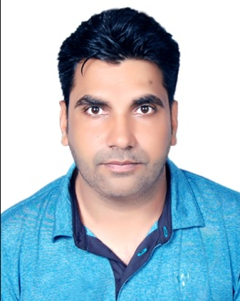 Distt. Sonipat, Haryana-131029

Contact No. :- +91-905 079 0607

Email Address :- [parveendahiya9107@gmail.com](mailto:parveendahiya9107@gmail.com)

**Career Objective**

I want to choose a career where I can enhance my skills and capabilities as a cricket coach and physical fitness trainer in your extreme institution with aim of achieving the organizational goal.

**Educational Qualification**

* B.P.Ed. from M.D.U. Rohtak
* Graduated EILLM University – Sikkim
* 12th passed – Haryana Open Board
* 10th C.B.S.E passed

**Professional Qualification**

* Certificate Course in Sports Coaching from N.I.S.

**Work Experience**

* Working in Distt. Cricket Association, Sonipat Since 2012.
* Working as physical teacher in The Vedic Era Progressive School Since 2014.

**Achievements in Sports**

* Represented Distt. Sonipat in Under 19, Under 22 & PATAUDI TROPHY.

**Languages Known**

* English, Hindi

**Date of Birth**

* 29/01/1987

**Strengths**

* Hard working
* Positive Attitude
* Desire to learn
* Confident
* High Sportsmanship

I am willing to be an effective cricket coach and perfect physical fitness trainer and I am willing to accept challenges and new responsibilities.

**Parveen Dahiya**